Stem cell therapy aims to help Nelson on road to recovery

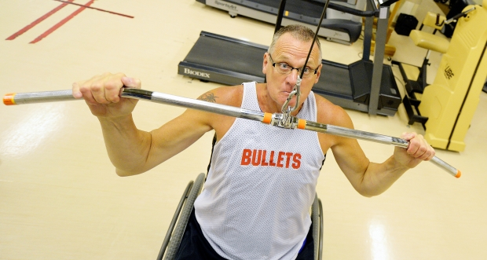

Glen Nelson, a former U of R Cougars basketball player, works out after an accident left him paralyzed from the chest down 11 months ago.

Glen Nelson has returned from Panama with more than just memories.
The former University of Regina Cougars basketball star is back in the Queen City with a renewed sense of optimism that he's on the road to recovery.
Nelson, 57, had back surgery Nov. 27, but awoke from the procedure paralyzed from the mid-chest down. A four-week regimen of stem cell therapy that he recently completed in Panama City has given Nelson a boost.
"The evidence is there that the stem cells are doing their business and the cells in the area of my spinal cord are making some detours (around the faulty area)," he said Wednesday.
"I've got this different feeling in my body with regards to pain. I can feel that some body functions are happening and I have different sensations in my body that I haven't had in the last 11 months."
Nelson headed for Panama City in late September, eager to diminish the pain he has felt in his back since his surgery. But before his treatments at the stem-cell clinic began, Nelson had to go through an evaluation process of sorts.
"One of the doctors said to me, 'You've got to get your head in the right space. You have to be positive. You have to really believe in this,' and I just started laughing at her," Nelson recalled. "I said, 'Sister, you're preaching to the choir. You have no idea who you're dealing with.'
"Once they got to know me, they were excited that I was so positive. Some of the people who go in there have their doubts, but I believe this is my chance."
Nelson's treatment included workouts at a local gym every morning, with sessions targeting his upper body on Mondays, Wednesdays and Fridays and his legs on Tuesdays and Thursdays.
He received injections of stem cells into the lumbar area of his back or intravenously into an arm on Monday, Wednesday and Friday afternoons.
The majority of the sessions involved donated umbilical-cord stem cells, while the last two sessions added stem cells cultivated from Nelson's bone marrow. Over the course of the four weeks, he received around 520 million stem cells.
Now it's up to his body. "They can't say for sure what's going to happen (as a result of the injections) because it's so individual," Nelson said. "Typically what they say happens is if you work your butt off, have a good head on your shoulders and follow a good diet, you'll see some significant changes in your situation within four to six months.
"My situation hopefully would be, No. 1, take away the majority of the pain and, No. 2, start moving (sensation) down throughout my body."
Things started changing even when Nelson was in Panama.
"I started to feel a difference in how my body was feeling," he said. "Then when I got home, I had three or four days of pretty intense pain in my back but it wasn't the same pain that I'd been suffering since last Nov. 27 when the accident occurred.
"When I started having pain in Panama, the doctor got excited. She said, 'That means the stem cells are doing their job.' Us old-school guys, it's no pain, no gain, right? That's the case with stem cells. You have to hurt before you heal."
Nelson said he had burning nerve pain in his buttocks and the back of his legs before he left for Panama. Now, he said that sensation has been replaced by a numbness akin to a limb after it has been slept on.
"All my pain is nervegenerated, so I feel that (the stem-cell therapy) is waking up my spinal cord," Nelson said. "Through a lot of meditation, I see my body changing.
"I don't see (numbness) as a step back at all. I'm moving forward with it."
Since returning from Panama on Oct. 18, Nelson has started going to the First Steps Spinal Cord Injury Wellness Centre. The facility tries to help people who have suffered spinal cord injuries increase function and regain mobility.
Nelson said he learned in Panama that nerves, like muscles, atrophy when they're not worked.
That led to a discovery during one of his first visits to First Steps.
"When we put on some electronic pads to send signals to my leg muscles to get some contractions going, nothing happened," Nelson said. "The therapist was pretty sure it was because the nerves had atrophied so dramatically.
"It took probably three sessions before I started to get little twitches and then my toes started wiggling and my hamstrings and quads had very small contractions. I've got to continue with that process."
He also plans to continue his daily workouts at the YMCA. On Nov. 14, he's to take possession of his new condo - a move he hopes will help him regain some independence.
A new wheelchair should help him with the process of reacquiring his driver's licence and the installation of hand controls in his vehicle will get him back on the road.
He's to return to Panama for another two-week session in four to six months, but in the meantime, he'll let the stem cells do their thing.
"People say, 'What's your hope?' Well, it's not my hope, it's my know - I know that this is going to work," Nelson said. "I believe 100 per cent in it and the proof has already started. At an early stage of the treatment, things are happening so I can't wait to see myself in four to six months ...
"I know it's going to diminish the pain. Then, if I were to look long term, it's certainly my goal to be up and going again in some form on my feet. I'm claustrophobic in this chair." Regina's basketball community is looking to help Nelson by holding a fundraising cabaret after the Cougars men's and women's games Nov. 7. The event, which also is to feature a silent auction, is to be held at the Owl.

